|  |
| --- |
| CPT_S 575 |
| EWB Data Analysis |
| Project Report |

|  |
| --- |
| Nathan Gray and Natalie Smith-Gray  12-12-2019 |

# Abstract

Washington State University chapter of Engineers Without Borders installed a solar powered water pump and water storage system in a remote location in Panama. Understanding how the system functions can help provide insight and optimize future designs within the same location as this project. This paper discusses the relationships identified between various features and it provides evidence that this water system is providing the community with enough water. This project ends with an optimization problem that is designed to determine parameters, such as pipe size and number of solar panels, to minimize the cost of the system. The optimization problem is conducted using average daily energy profiles found within the data. It was determined that one-inch pipes would have been the optimal size for this system. Collecting more data overtime will allow for further analysis of the system and supervised learning to help design other similar projects within the same location.

Table of Contents

Abstract 1

Introduction 3

Problem Definition 3

Models/Algorithms/Measures 3

Implementation/Analysis 3

Adjusting for voltage drop to pump 3

Correlations 4

Wind Energy 6

Optimization 7

Results and Discussion 10

Conclusion 11

Resources 12

# Introduction

In June 2019, The Washington State University chapter of Engineers Without Borders (EWB-WSU) installed a solar powered water pump and water storage system for the community of Nueva Esperanza in the Ngobe-Bugle Comarca in Panama. The Ngobe-Bugle Comarca is a native Panamanian reservation similar to Indian reservations in the United States. The pump is powered by a 1.425kW solar array. It pumps water from a spring in a ravine 110ft below the community to two 800-gallon storage tanks on a hill a short distance from the homes. The pumping system saves the residents the backbreaking work of carrying buckets of water up steep jungle slopes from the spring to their homes.

With the help of Kilowatts for Humanity (KW4H), EWB-WSU installed a data acquisition system (DAS) that makes measurements of system quantities such as solar panel voltage and current, and solar irradiation flux and sends the data, via cell towers, to a server where it can be viewed online. Also, a weather station is located next to the solar panels and gathers useful data that is transferred to a program called Zentra Cloud.

# Problem Definition

The goal of this project was to explore the data provided by the DAS and weather station. Identify patterns, understand how well the system is working for the community, and optimize the system for future implementations in the villages within the Ngobe-Bugle Comarca.

# Models/Algorithms/Measures

To complete our goal, we mainly focused on using Exploratory Data Analysis (EDA) on our data. Our EDA was done through scatter matrixes, plots, and graphs. Originally, we wanted to use supervised learning to predict the amount of water that would be used by the community. However, our data only contains 14 days of data due to a lightening strike putting the DAS out of commission. Therefore, there was not enough data to conduct supervised learning. Recently, a team went to Panama during a school break and were able to fix the DAS. We plan to use supervised learning on the data once more is gathered.

# Implementation/Analysis

## Adjusting for voltage drop to pump

Working with two data collection systems, the Data Acquisition System and the weather station, required tidying up the data. This involved working with missing data, separating time stamps, etc. Adjusting the voltage drop from the solar panel to the pump was one example of tidying up data to be used later in our analysis. The pump voltage is different from the solar power voltage, due to resistance in the wire. This can be calculated using equation (1).

The wire gage used for this pump system was 10 AWG which has a resistance (r) of 0.0009989 ohms per feet [1]. With the length of the wire from the solar panel to the pump being 750 feet, it is possible to compute the total wire resistance using equation (2).

It is then possible to use this total wire resistance (R) with the current data to calculate the voltage drop, power loss, and power consumed by the pump.

## Correlations

We then wanted to look for any correlations within the data. This was done by initially creating a scatter matrix of the various variables as seen in Figure 1. At a glance, you can see that there is a strong correlation between flux (solar irradiance) and current_cal (calibrated current measurement). Temperature is correlated with flux as we would expect. The variable, in_rate, measuring pump flow rate, also shows a correlation with flux and current. There is an intriguing relationship between current and voltage as well.

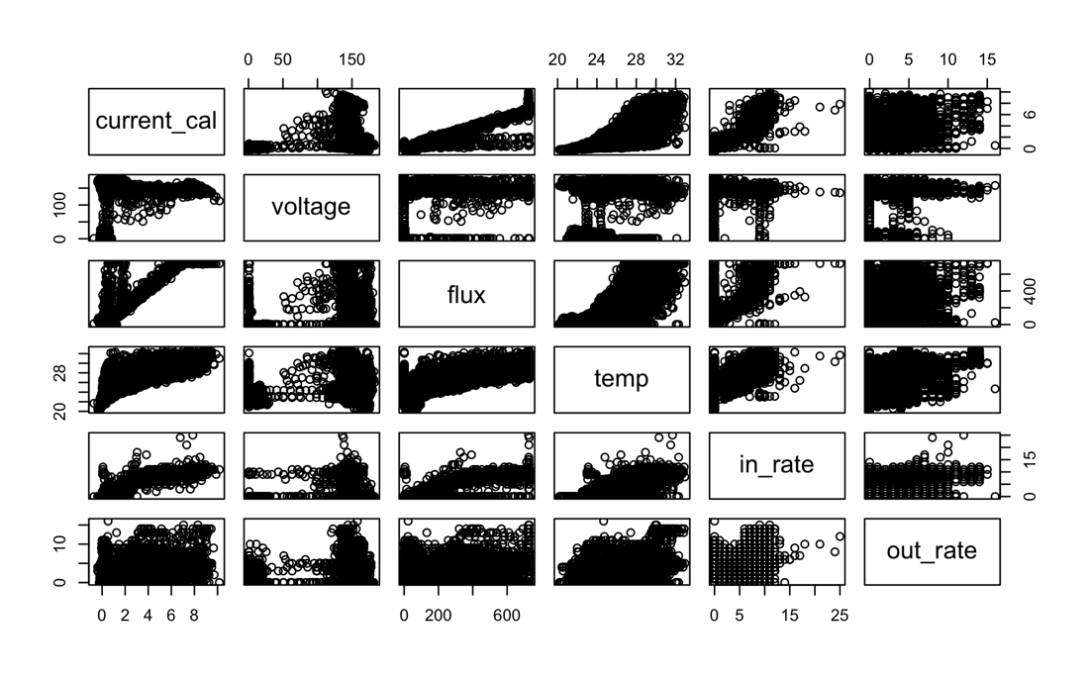

Figure . Scatter Plot

After correlations were examined among various variables, we decided to focus on a few specific ones. The first was power versus solar flux or irradiation as shown in Figure 2. The relationship here is neatly linear. A linear fit of this data reveals relationship of equation (3). This relationship may be very useful in the future if we use this same pump for a future project.

Figure System power consumption vs. solar irradiation.

The next visualization was the pump flow rate versus the power the pump consumed (Figure 3). This relationship is not as clear. The data is fit with a model of the form y=ax^(1/2) + bx + c. The relationship is as described by equation (4).

Figure Pump flow rate versus the pump power consumption.

The main reason EWB-WSU installed this system for the community was to provide water. Therefore, it was pertinent to see if the community was getting enough water. As shown in Figure 4 the blue dots represent the water used and the red dots represents the water pumped.

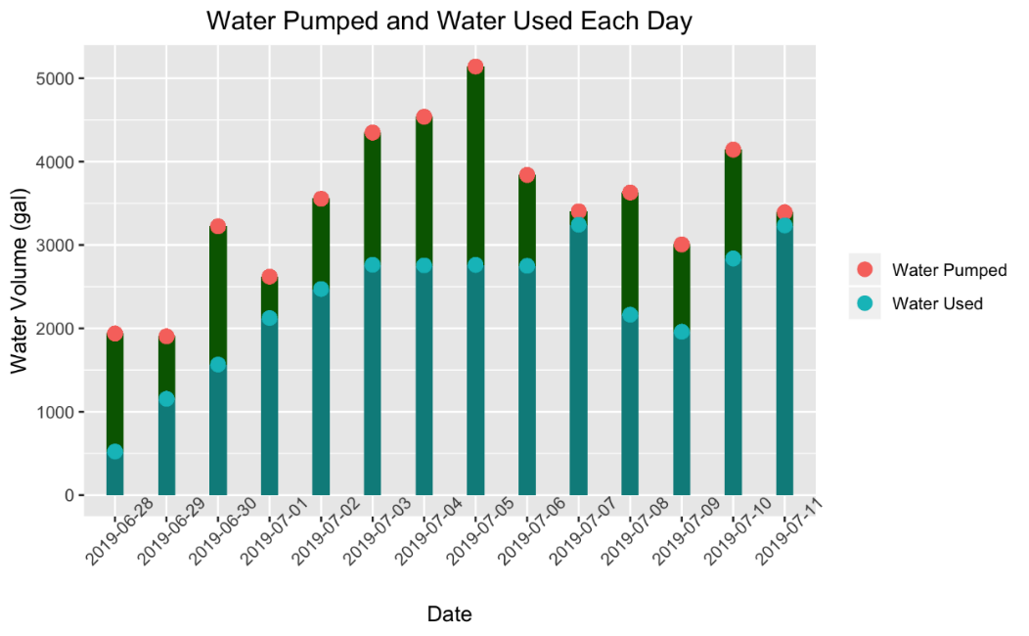

Figure . Water Provision and Usage

When this solar panel pump system was installed, it was determined that the system did not need a float valve to stop the water tanks from overflowing. At this moment, the tanks fill up and excess water runs down a hill. As discussed further in the results section, it is optimal to install a float switch for this system.

## Wind Energy

We wanted to look at weather data to determine if wind was a feasible option for powering the system. Details may affect the wind power, such as location and size of wind turbine. Having several options as a power source may be useful if a community we want to help is located in a shady location where solar panels may not be useful. As shown in Figure 5, the wind power can vary on a day to day basis (some days are windier than others which may be the reason for the wind power outlier on 07/07/2019).

Figure . Wind vs Solar Power

The calculation that was used to calculate the wind power is shown in equation (5) [2].

Where Pwind is the amount of wind power in Watts, ρ is the density of the air in kg/m^3, d is the diameter of the wind turbine blade measured in meters, and v is the wind speed in meters per second. We got the wind speed from the weather station data. The density of the air used was 1.225 kg/m^3 which is the standard density of air at sea level and 15 degrees Celsius. For the purpose of this analysis we sized the turbine so that it would produce about the same amount of power as the solar panels. The diameter of the turbine to achieve this is 15 meters.

## Optimization

Finally, we wanted to optimize the system. To understand how to improve the system, it is important to know how losses are created in the system. Figure 6 is the pump curve for the Grundfos 11 SQF-2 pump [3]. The left axis represents the flow rate in gallons per minute for the pump, the bottom axis is the pump power in kilowatts, and the right axis is the efficiency of the pump. Each of the vertical blue curves represents the pump curve for a pump operating at a different amount of head pressure. Our system has 110 ft of head which would be a line somewhere between the line labeled 98 and the line labeled 131. We added the red curve and the three large dots on top of the figure to help us understand how the system operates relative to the pump specification. Each dot is located where the pump would be expected to operate when pumping 10 gallons per minute based on the amount of pressure added from friction. The yellow dot represents a zero-friction pipe, the blue dot represents a one-inch pipe, and the green dot represents a three-quarters inch pipe. The red line shows the data fit (equation 2) which was made with three-quarter inch pipe. The information for determining where each of these dots belongs came from [4].

This red line and the green dot are relatively close to each other, which means the system is performing as expected with the pipe size it has. However, it is shown in Figure 6 that the blue dot requires less power to pump the same amount of water as the green dot. The yellow dot is even less, but a frictionless pipe is not realistic. The question is, based on the energy data of the real system, is it more cost effective to buy more expensive one-inch pipe and therefore require fewer solar panels, or pay more for solar panels and less for three-quarter-inch pipe.

Figure . Grundfos pump curves.

Our optimization problem was set up as follows:

Minimize:

w.r.t.

s.t.:

Where Cpv and Cpipe is the cost of the solar panels and the cost of the PVC pipe for the water. This was then further broken down into ppv and ppipe which is the price of the solar panels and the PVC pipes, hrsun was the number of sun hours for the implementation site, Npipe is the number of pipes used for the system, and E which is the energy used to pump the water (also the unknown in our problem). Qmin is the minimum amount of water the system should provide to the community each day and is set equal to 3500 gallons (a value obtained from EDA on the data). The function Q(E, spipe) is the water provided based on the solar energy and the size of the pipe.

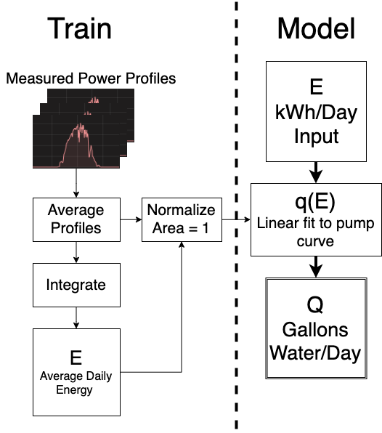The difficult part of this optimization was creating the model Q(E, spipe), which takes as inputs, the pipe size, and the total average energy provided by solar panels per day. The output is the average volume of water pumped per day. The challenge was that the function that we developed from the data shown in Figure 3 is based on the power measurement each minute and the volume pumped each minute. We addressed this by making an average power profile from all of the data and normalizing it so that it has an area of one. The normalized profile can be scaled by multiplying it by the input ‘E’ value. This essentially simulates what power the system would produce each minute with a solar array of arbitrary size. We generated two equations similar to equation (4), one for a one-inch pipe and one for a three-quarter-inch pipe. To produce both equations in a consistent way, we fit the models to points produced using tables of PVC friction loss data from Engineering Toolbox for different flow rates [4]. These equations allowed us to convert the power profile into a water flow profile for either pipe size. The total volume of water per day is simply the integral of the water flow profile. This method is illustrated in Figure 7.

Figure . Process of creating a model to calculate average water pumped per day from average solar energy produced per day.

The length of the pipe used for the system was 750 feet, which totaled to a number of 75 pipes each at 10 feet long. The price for the one-inch pipe was $3.57 and for the three-quarter inch pipe was $2.44 [5, 6]. The number of sun hours was provided by Global Solar Atlas and came to approximately 5 hours [7]. The price of the solar panels is approximately $1.25 per Watt for 285 W solar panels. These values were used with the E value (discussed previously) to find the minimized cost as reported in the results section.

# Results and Discussion

From Figure 4, we can see that there is an excess amount of water provided to the community and a float value would be useful to provide the community with enough water and not be wasteful. The community also asked our EWB chapter to fix the overflowing water, which confirms what we see in Figure 4.

For the wind generator to provide a similar amount of energy as the solar power, the blade diameter must be approximately 15 meters (approximately 49 feet). To install and maintain a wind turbine with this size of blade is unrealistic for a small rural village. Therefore, unless the village we will be working in in the future is located in a windier location, wind energy is probably not feasible.

As shown in Figure 6, we can see that there is significant loss in the pipe friction. We can also use this information to determine if it is cost effective to reduce pipe friction losses. Additionally, this information gives us the link between the electrical characteristics and the hydrological characteristics of the system.

Table . 3/4" Pipe Analysis Table

|  |  |  |  |
| --- | --- | --- | --- |
| Model Validation | Average daily volume water predicted by model (gallons) | Actual average daily water pumped  (gallons) | % Error |
| ¾” Pipe | 2211 | 3,477 | 36 |

Table . Cost Table

|  |  |  |
| --- | --- | --- |
| Optimization Results | Cost | Solar Capacity Required |
| ¾“ Pipe | $ 1448.94 | 1012.75 |
| 1” Pipe | $ 1062.29 | 635.63 |

For the actual built system, the three-quarter inch pipe was chosen due to the pipe having a lower cost than the one-inch pipe. After analysis of the data, the one-inch pipe shows to provide a lower cost than the three-quarter inch pipe (see Table 2). Before using this method directly for system design; however, future work should improve the model to reduce the percent error to a reasonable level.

# Conclusion

Conducting data science on the gathered data for this project has been insightful for many reasons. It was confirmed that the community has been receiving an adequate amount of water, and it was concluded that a float switch would be useful for the system. This was also asked for by the community which confirms what has been discovered in this data. Several correlations were made during exploratory data analysis. One of which was power versus flux, which is quite linear. Finally, using optimization we discovered that using a one-inch pipe would be optimal for this system. However, due to the 36% error we found for the model, this conclusion is not certain.

Due to a lightning strike on the system, the data we collected only covered fourteen days during the wet times of the year. We hope to gather more data over the year to identify time series patterns within the data and to use supervised learning to predict the usage of water by the community. This would be useful for designing future systems in the Ngobe-Bugle Comarca.

# Resources

[1] “Electrical Wire Gauges.” [Online]. Available: http://hyperphysics.phy-astr.gsu.edu/hbase/Tables/wirega.html. [Accessed: 12-Dec-2019].

[2] “Wind Power.” [Online]. Available: https://www.engineeringtoolbox.com/wind-power-d_1214.html. [Accessed: 10-Dec-2019].

[3] “11 SQF-2.” [Online]. Available: https://product-selection.grundfos.com/product-detail.product-detail.html?from_suid=157612206426006986364843561976&pumpsystemid=738883958&qcid=738884049. [Accessed: 11-Dec-2019].

[4] “PVC Pipes - Friction Loss and Flow Velocities Schedule 40.” [Online]. Available: https://www.engineeringtoolbox.com/pvc-pipes-friction-loss-d_802.html. [Accessed: 11-Dec-2019].

[5] “Charlotte Pipe 3/4 in. x 10 ft. PVC Sch. 40 Plain-End Pipe-PVC 04007 0600,” *The Home Depot*. [Online]. Available: https://www.homedepot.com/p/Charlotte-Pipe-3-4-in-x-10-ft-PVC-Sch-40-Plain-End-Pipe-PVC-04007-0600/100348472. [Accessed: 11-Dec-2019].

[6] “1 in. x 10 ft. PVC Schedule 40 Plain-End Pipe-531194,” *The Home Depot*. [Online]. Available: https://www.homedepot.com/p/1-in-x-10-ft-PVC-Schedule-40-Plain-End-Pipe-531194/202280936. [Accessed: 11-Dec-2019].

[7] “Global Solar Atlas.” [Online]. Available: https://globalsolaratlas.info/map?s=8.412602,-81.732788&m=site&c=8.708644,-82.029419,8. [Accessed: 11-Dec-2019].

# Supplemental Material

The code for this project can be found at: